# Les 3 – Storyboarding

Storyboard Pro:

* Vectorieel maar met brushes
* A screen shot of a computer

  Description automatically generated

## Camera bewegingen

* Camera keyframes

* Camera tools

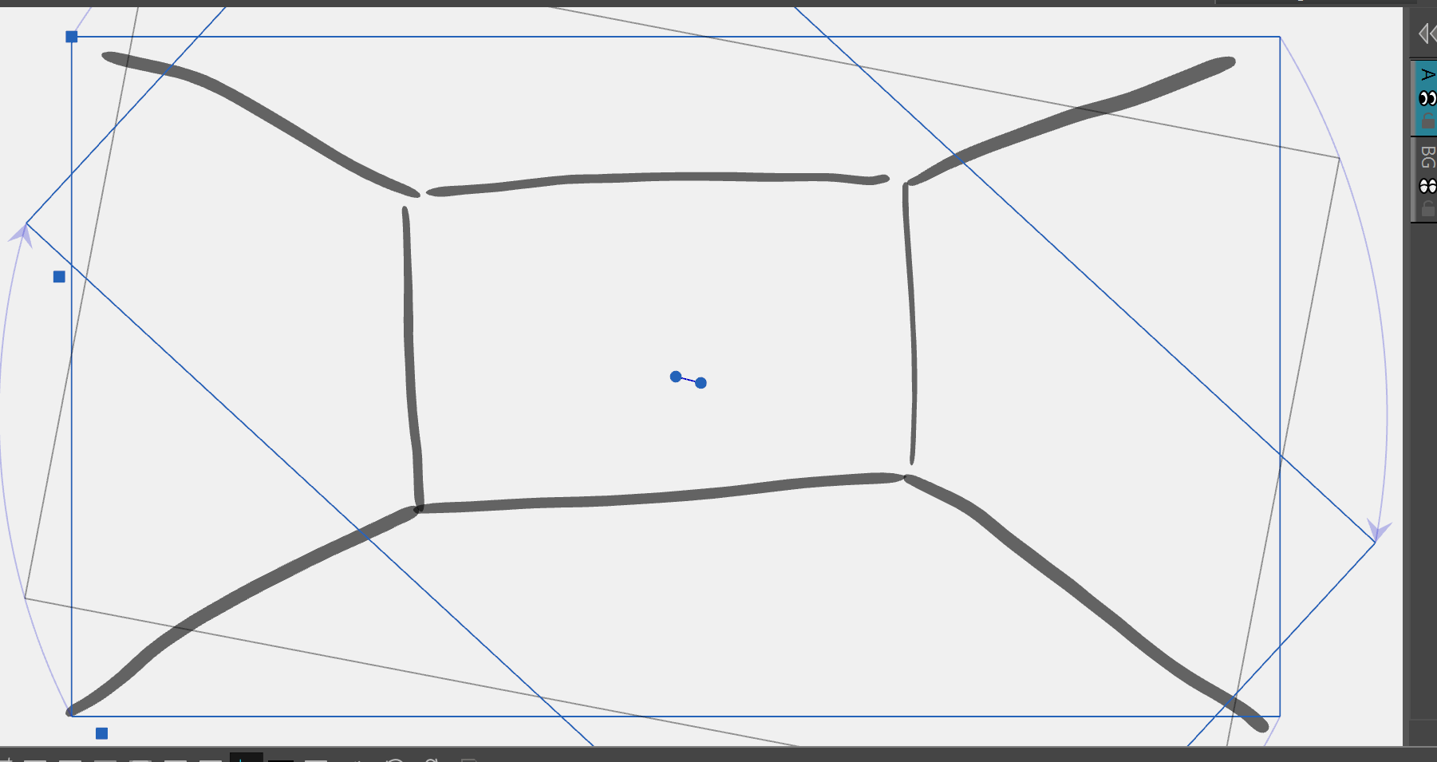

* Camera transform

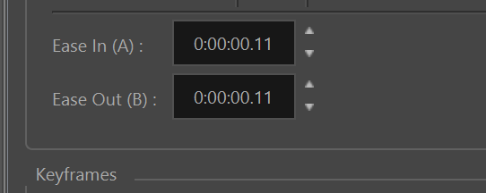

* Camera easing in tool properties

* Storyboard the green mile